Coordinator: Radulescu Vlad Team: Ciucanel Adrian
Filimonov Alexandrina
Nistor Irinel
Students Management
Short description of the project
Students Management aims to help college staff to manage students and their status at subjects they are assigned to. The project is designed to ease the work of teachers and secretaries when it comes to decide whether a student is promoted and what position he/she has in semester or yearly hierarchy.
The project was developed in three phases: in first phase we worked on functionality and in the second two we focused on testing.
The project was developed using C# language and ASP.NET Web API framework for back-end functionality and HTML/CSS/Javascript for front-end.
Use cases
Users of this application can insert a list of students and subjects and assign students to subjects. This can be done by introducing information about each student, one by one or by uploading a file with relevant data and then assign them to subjects. Every time a student gets a grade, his status is updated.
At any moment the user can see student’s grades and at the end of each semester a ranking of students is made to see who is promoted and whether he will be financed or fee payer.
The user can get at any moment the list of students by downloading it in a .csv file.

Implementation details
The project has the following modules:
Database system
Because the goal of the project wasn’t to prove that we can work with a database server, we chose to keep our data in few .csv files, so we ended up having students.csv, subjects.csv and studentsToSubjects.csv.
Module for input/output management
For this module we provide two ways for data input: web interface and import functionality which means uploading a .csv file.

Module that carries out the operations required by the management process
For this module we developed a REST API which is responsible for input and output of data and for all the operations required by process of classifying students, getting their academic status and establishing whom is promoted.
REST API was developed using ASP.NET Web API framework. It has two controllers that provide access to service methods: StudentController and SubjectController.
The calls to the api are made using this pattern
api/Student/Add
api/Student/Details
api/Student/Download
api/Subject/Update/id
The controllers use services that implement IDataLayer interface. To make code easier to test we implemented dependency injection pattern using Unity container.
User Interface module
The application has a web interface, that can be opened with any web browser. For visual part we used HTML and CSS and for comunicating with application's controllers and associating different actions to the interface buttons we used Javascript.
As libraries of the technologies that build the web interface, Bootstrap and jQuery enhance the CSS, respectively the Javascript. Bootstrap offeres predifined CSS classes that can be applied to the HTML tags, in this way speeding up the development process and the build quality of the interface. On the Javascript side, jQuery enhance the comunciation with the controllers of the application, offering an easy way to create a HTTP request and also allows easy management and customisation of the HTML tags once a HTTP response is received.
As the structure of the UI module we have the folloing HTML pages: Student.html, StudentAdd.html, StudentDetails.html, Subject.html and SubjectAdd.html.
Student.html page contains the students table that display each student that exists in the database. StudentDetails.html contains the information about one student. It also works as a form wich has it's fields already completed and if the user want to update one of the items, it can do so and then press Update buton. In this way the new data is saved in database. StudentAdd.html represents a form that can be completed with information about a new student and press submit to save it in database. Subject.html page works as Student.html and display the available subjects in a table. SubjectAdd.html is a form that can be used to add new subjects.
The Javascript is structered in a couple of files each one with its own role. Service.js file defines the part of the javascript that send and receive HTTP requests, respectively responses. It makes an abstraction about what data is sent and what data is received and also about the URL where the requests are sent. As concrete implementation of the comunication module of the user interface there are StudentService.js and SubjectService.js files. This defines the exact URL where the requests wil be sent and also defines the actions that must be executed when the response is received. This two files are used in Student.js, StudentAdd.js, StudentDetails.js, Subject.js and SubjectAdd.js files. The list of mentioned javascript files are specific to each HTML page previously explained. In each one, the actions needed for HTML buttons are set and also the data is retrieved from the controllers in order to populate the pages with students or subjects, depending the case.
Operations required by the management process related to college rules
The rest api call api/Student/Details will return the json reprezentation of a student alongside details about his academyc year status, like: the number of credits, the ECTS average and all its grades. The request will contain a query object, formed from three integer values representing the id of the student, the academic year and the semester and this values will determin the details returned.
The budget status of all the students can be determined by the call api/Student/Budget . This call will return a josn array containing all the students, allongside their points and a flag stating if the student is financed or a fee payer. The budget status is determined in the followin way: the first 60% in descending order by their points will be financed the other 40% will be fee payers.
The promotion details of the students can be determined by the call api/Student/Promotion. This call will return a jason array containing all the students, allongside a flag that determines if the student was promoted or not. The promotion status is calculated by checking if a student has less then 6 subjects failed.
Testing details
To test the project’s functionalities we used unit testing and assertions. In testing phase we used Moq framework and DataContracts for back-end testing and Jasmine for front-end.
We wrote unit tests for controllers, for DataLayer class and for the class responsible to establish academic status of students. In order to test the controllers and the DataLayer class we mocked the classes they were dependent on.
The tests on the controllers checked if the right service methods are called and if the returned results are correct.
For the DataLayer it is important to mention that we mocked the reading and writing of files, in order to test the component independently of the I/O layer.
- For reading we mocked the read method to return the values from an array of strings, consecutively
- For writing we verified that the specified values where passed to the write method as parameters
For example, for testing the update method first we mocked the read to return three different entities. We selected the last one to be updated and we verified that the first two were written unmodified and the last was written modified by the mocked write in file method.
In the case of the CollegeRules class, we added tests for both normal, expected cases and also for unexpected cases, where the input is outside of the required bounds. For example when testing the GetTotalCreditsPerYear, two cases were considered:
- In the first case some of the subjects of the student used in the test were studied in the semester considered to be the present semester in the moment of the execution of the test. The test verified that only the subjects studied in the current semester are considered in the calculation of the number of the credits
- In the second case none of the subjects of the student were in studied in the current semester. The test verified that the number of credits returned was zero.
User interface testing
As for the user interface, the only code that can be tested is the Javascript code. We achived to create unit tests for it by using Jasmine library.
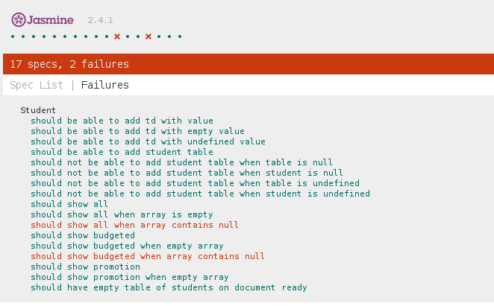
The presented image represent the report generated when the tests were ran. Each test has its own description which is basicaly the test scenario. The unit tests are asserting that the HTML tags has the correct attributes set and also if the data passed as paramter to tested functions is displayed correctly in the browser. As example, the test named „should show all”, test the Javascript funcion that displays the array of students passed in as parameter. We created some test data by instantiating some Stundents objects and place them in an array. We called the method that displays the student table and send the test data as parameter. In the last part we assert that the HTML code that is generated by the function is the one that we expect. Also, for the same function we created a couple of more tests that calls it with an empty array and also with an array that contains a null object. The last one, as it can be observed in the image, failed.
Also we created exception.js file which defines the mechanism used to check preconditions and postconditions. There are two Javascript functions that receives as paramters a boolean expresion and a string. In case the boolean expresion is false, then it throws an exception wich has as message the string recieived as second parameter. We added precondtions and postcondtions for different functions. In general, as precondtion, we check that the HTML tags that are used in a function exists and also if the parameters received are valid. As postconditions, we checked that the new generate HTML tags exists and contains the correct information. For example, in the function that fill the table which student data, we added as preconditions the fact that the table exists as HTML tag, before filling it with data and as postconditions we checked that the number of added rows is equal with the number of students from the array received as parameter.

